Juan’s Mobile Network: What’s Causing Customer to Churn?
Juan Villegas
MAT 342 Explorations in Data Science
January 7th, 2022

Table of Contents
Table of Contents 2
Part 01: Data Exploration 3
Day Minutes 3
International Plan 4
Voice Mail Plan 5
Customer Service Calls 6
Establishing the C5.0 Model 7
Validating Our Partitioned Data 7
Validation for Numeric Data 8
Validation for Categorical Variables 9
Establishing a Baseline for Our Model 10
Baseline Model Table 10
Figure 7 Shows a table of the target variable Churn. 10
Using Figure 7, to get a baseline accuracy of our model, we add both columns together, then divide by the first. Our accuracy is 85.50% (2850/3333 = 0.8550855). 10
C5.0 Model 11
Evaluating Our Model 12
Appendix 13

Data Exploration
In this section we will create 2 of the same histograms with different positions for each of our 4 predictor variables: Day Minutes, International Plan, Voice Mail Plan, and Customer Service Calls. We will include an overlay of Churn (our Target Variable) to get better insights from the data that we have.
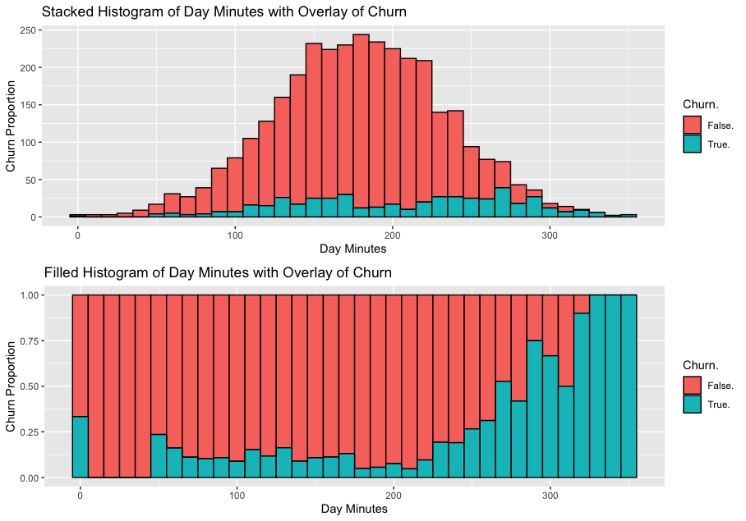
Day Minutes

Figure 0 Shows a Stacked (1) & Filled (2) Histogram of Day Minutes with an overlay of Churn
Figure 0 (1), Shows us that the model for non-churning customers is almost normal. We can’t see much of a patter for the churning customers. Luckily, our stacked histogram shows us a clear pattern for customers that churn. After about 200 minutes of Day minutes, customers churn more.
International Plan 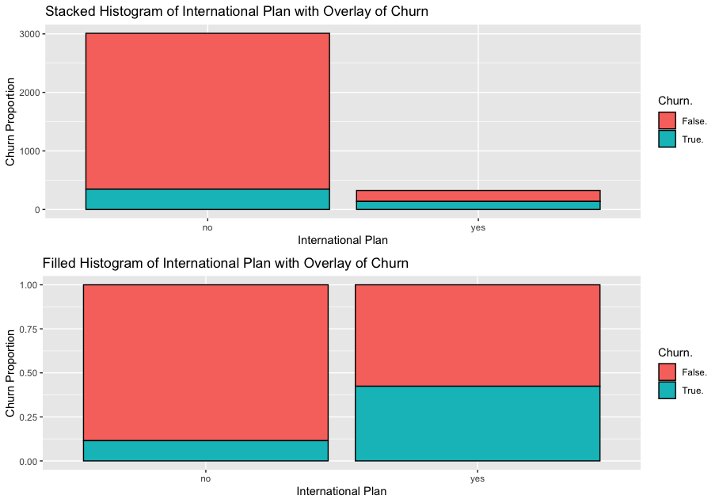
Figure 1 Shows a Stacked (1) & Filled (2) Histogram of International Plan with an overlay of Churn
In Figure 1 (1), we can see that a big proportion of people who don’t have an international plan, do not churn but, Figure 1 (2) shows us that once customers have an international plan, 45% of them churn.

Voice Mail Plan 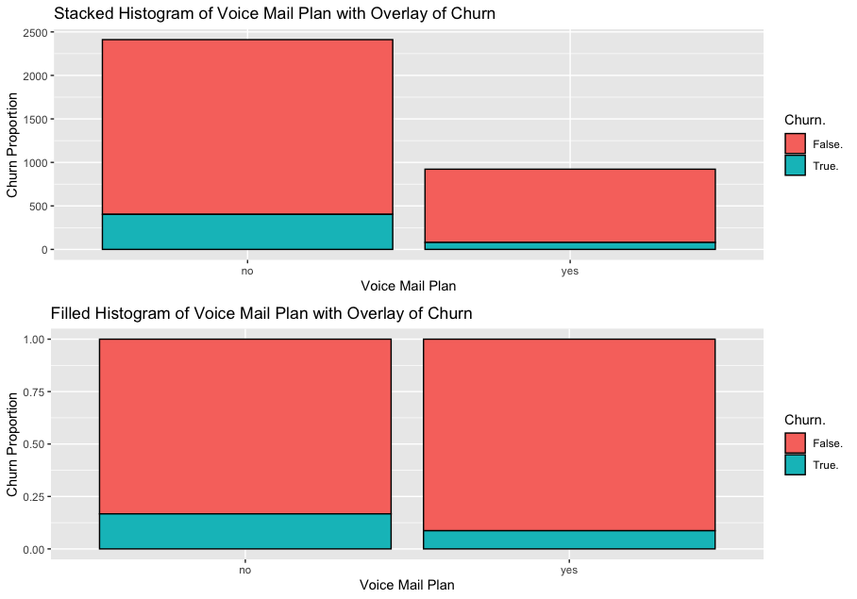
Figure 2 Shows a Stacked (1) & Filled (2) Histogram of Voice Mail Plan with an overlay of Churn
In Figure 2 (1), we can see that a big proportion of people who don’t have a voice mail plan, do not churn. Figure 1 (2) shows us that even customers that have voice mail plans churn less than the ones that don’t have a voicemail plan.

Customer Service Calls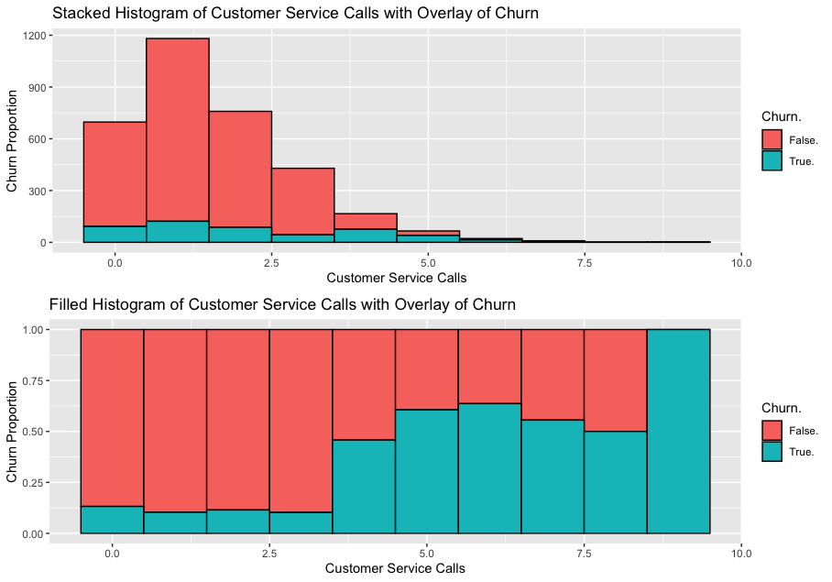
Figure 3 Shows a Stacked (1) & Filled (2) Histogram of Customer Service Calls with an overlay of Churn
In Figure 3 (1), we can see that our data for non-churners is skewed right but, we can’t see much of a pattern for churners. When we look at Figure 3 (2), we can see that between 0 and 3 customer service calls, we have a low rate of churners but, once the customer service calls is more than 3, the churning rate increases drastically.

Establishing the C5.0 Model
In this section we begin to establish our C5.0 Model. Before creating it we must do 2 things:
- Validate our partitioned Data
  - Numeric is validated by:
    - Similar looking boxplots
    - P-Value bigger than 0.10
  - Categorical data is validated by:
    - P-Value being Bigger than 0.10
- Establish a Baseline for our Model
After we have done these two things, we will begin to build our C5.0 Model.

Validating Our Partitioned Data
In our data, we have 2 different types of data. Numeric, and Categorical.
For our numeric data, we have:
- Day minutes
- Customer Service Calls
For our Categorical data we have:
- International Plan
- Voice Mail Plan
We need to validate these variables.

Validation for Numeric Data
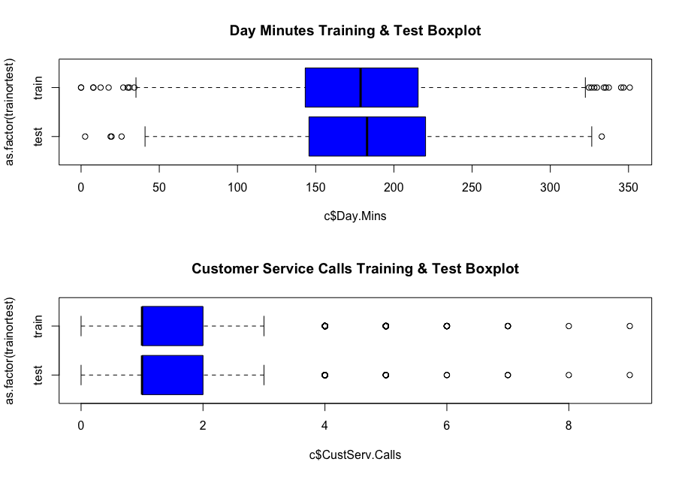
As explained before, to validate Numeric Data we need to do two things. Create boxplots for the Testing & Training Data to make sure they are similar, and the p-values have to be bigger than 0.10.
Figure 4 Shows 2 boxplots for each of our variables. Boxplots (1) shows a boxplot for the training & test data of Day minutes. Boxplots (2) shows a boxplot for the training & test data of Customer Service Calls.
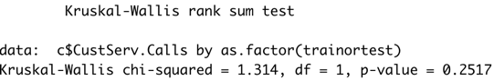
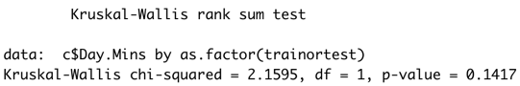
In box the variables boxplots (1 & 2) we can see that the boxplots are similar, meaning they pass the first condition. Looking at the Kruskal-Wallis test (to the right), we can also see that both variables have P-Values over 0.10. Our Numeric Variables are validated.

Validation for Categorical Variables
To validate Categorical Data, we only need to do one thing: make sure the p-values are bigger than 0.10.
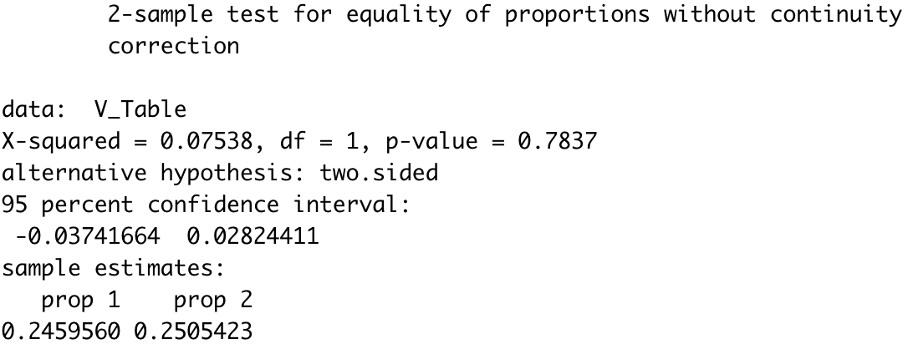Figure 5 Shows a 2-sample test for equality of proportions without continuity correction for the Voice Mail Plan Variable. The P-Value is 0.7837.
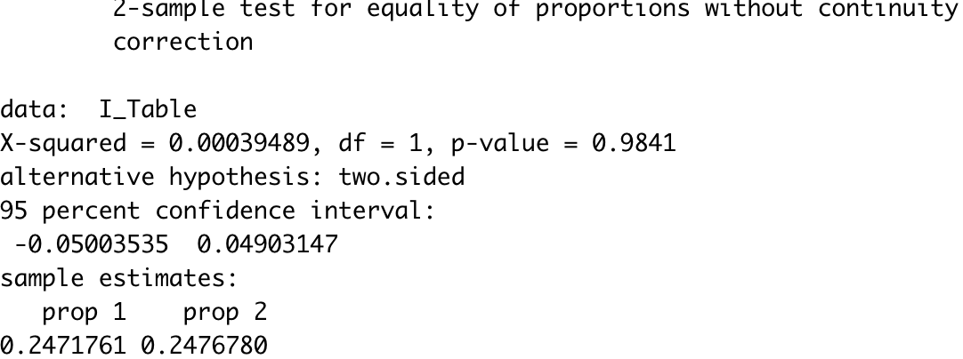Figure 6 Shows a 2-sample test for equality of proportions without continuity correction for the International Calls Variable. The P-Value is 0.7837.
Figure 5 & 6 validates our categorical data because both the P-Values are way bigger than 0.10. We are ready to establish a baseline for our model.

Establishing a Baseline for Our Model
To establish a baseline for our model we will create a table of our target variable (Churn.), add the 2 columns and then divide by the first column. This will give us the baseline model’s Accuracy.

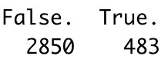
Baseline Model Table
Figure 7 Shows a table of the target variable Churn.
Using Figure 7, to get a baseline accuracy of our model, we add both columns together, then divide by the first. Our accuracy is 85.50% (2850/3333 = 0.8550855).

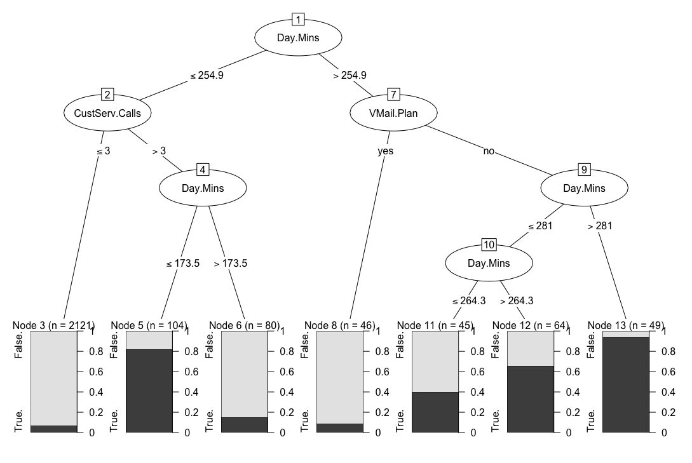
C5.0 Model
Figure 8 Shows the C5.0 Model for our customers that Churn
Figure 8 is the C5.0 Model for our target variable Churn. Focusing on the three largest segments of this Model we can understand that: If you are a customer who doesn’t have a voicemail plan and use more than 285 Minutes, then you are 93.88% likely to churn. If you are a customer who doesn’t have a voicemail plan, but your day minutes are less than 281 but more than 265, then you are 65.63% likely to churn. If you are a customer who has contacted customer service more than 3 times and day minutes are less than 174, then you are 81.73% likely to churn.

Evaluating Our Model
To evaluate our model, we must use our training data set & model it against foreign data (our testing data). We will then create a contingency table of Actual VS Predicted values that our Model created. After that we will see the Accuracy, Sensitivity and Specificity of our model.

Actual | Predicted
 | Churn False (Negative) | Churn True (Positive) | Total
Churn False (Negative) | 676 (TN) | 21 (FP) | 697
Churn True (Positive) | 75 (FN) | 52 (TP) | 127
Total | 751 | 73 | 824
Table 1 Shows the Actual vs Predicted Values of C5.0 Model for our customers that Churn

Accuracy and Overall error rate
Accuracy = (TN + TP)/ Overall Total = (676 + 52) / 824 = 0.88349515
Error Rate = 1 – Accuracy = 1 - .88349515 = 0.11650485
Our model correctly classifies customers that churn 88.35% of the time, and incorrectly classifies customer that churn 11.65% of the time.

Sensitivity and Specificity
Sensitivity = TP / (TP + FN) = 52/127 = 0.19685039
Our Model found 19.69% of all customers who churned.
Specify = TN / (TN + FP) = 676/697 = 0.96987088
Our model found 97% of all customers who didn’t churn.

False Positive Rate and False Negative Rate
FPR = 1 – Specificity = 1 – 0.96987088 = 0.03012912
We incorrectly identify non-churning customers as churning customers 3% of the time.
FNR = 1 – Sensitivity = 1- 0.19685039 = 0.80317961
We incorrectly identify churning customers as non-churning customers about 80.31% of the time.

Proportion of True Positive, Proportion of True Negative, Proportion of False Positive, Proportion of False Negative
PTP = TP / (TP + FP) = 52/73 = .71232877
Out of all customers that we classified as churners, we are correct 71.23% of the time.
PTN = TN / (TN + FN) = 676 / 751 = 0.90013316
Out of all customers that we classified as non-churners, we are correct 90% of the time.
PFP = 1 – PTP = 1 - 0.71232877= .2876123
Out of all customers that we classified as churners, we are incorrect 28.76% of the time
PFN = 1 – PTN = 1 – 0.90013316 = 0.09986684
Out of all customers we classified as non-churners we are incorrect 10% of the time.

Full interpretation of our model
Overall, our model correctly classifies customer churn rate about 88% of the time. However, out of all churning customers that we could have been found using this model, we only found about 20% of them., Whereas we found about 96% of all non-churning customers.
Our model risks classifying non-churners customers as high income about 3% of the time. On the other hand, we risk classifying churners as non-churners about 80% of the time.
About 71% of the churning customers our model predicted churned. About 90% of the customers that our model classified as non-churners were non-churners.

Appendix
churn_train$trainortest <- rep("train", nrow(churn_train))
churn_test$trainortest <- rep("test", nrow(churn_test))
c <- rbind(churn_test, churn_train)
summary(c)
#Graphical Displays
library(ggplot2)
library(gridExtra)
#Day Mins
a<- ggplot(c, aes(Day.Mins)) + geom_histogram(aes(fill = Churn.), color = "black", binwidth = 10, position = "stack") + xlab("Day Minutes") + ylab("Churn Proportion") + ggtitle("Stacked Histogram of Day Minutes with Overlay of Churn")
b<- ggplot(c, aes(Day.Mins)) + geom_histogram(aes(fill = Churn.), color = "black", binwidth = 10, position = "fill") + xlab("Day Minutes") + ylab("Churn Proportion") + ggtitle("Filled Histogram of Day Minutes with Overlay of Churn")
grid.arrange(a,b)
#International Plan
d <- ggplot(c, aes(c$Int.l.Plan)) + geom_bar(aes(fill = Churn.), color = "black", position = "stack") + xlab("International Plan") + ylab("Churn Proportion") + ggtitle("Stacked Histogram of International Plan with Overlay of Churn")
e <- ggplot(c, aes(c$Int.l.Plan)) + geom_bar(aes(fill = Churn.), color = "black", position = "fill") + xlab("International Plan") + ylab("Churn Proportion") + ggtitle("Filled Histogram of International Plan with Overlay of Churn")
grid.arrange(d,e)
#Voice Mail Plan
f <- ggplot(c, aes(c$VMail.Plan)) + geom_bar(aes(fill = Churn.), color = "black", position = "stack") + xlab("Voice Mail Plan") + ylab("Churn Proportion") + ggtitle("Stacked Histogram of Voice Mail Plan with Overlay of Churn")
g <- ggplot(c, aes(c$VMail.Plan)) + geom_bar(aes(fill = Churn.), color = "black", position = "fill") + xlab("Voice Mail Plan") + ylab("Churn Proportion") + ggtitle("Filled Histogram of Voice Mail Plan with Overlay of Churn")
grid.arrange(f,g)
h<- ggplot(c, aes(CustServ.Calls)) + geom_histogram(aes(fill = Churn.), color = "black", binwidth = 1, position = "stack") + xlab("Customer Service Calls") + ylab("Churn Proportion") + ggtitle("Stacked Histogram of Customer Service Calls with Overlay of Churn")
i<- ggplot(c, aes(CustServ.Calls)) + geom_histogram(aes(fill = Churn.), color = "black", binwidth = 1, position = "fill") + xlab("Customer Service Calls") + ylab("Churn Proportion") + ggtitle("Filled Histogram of Customer Service Calls with Overlay of Churn")
grid.arrange(h,i)
##Boxplots for Numeric Validation
set.seed(69)
par(mfrow=c(2,1))
boxplot(c$Day.Mins ~as.factor(trainortest), data = c, horizontal = TRUE, main = "Day Minutes Training & Test Boxplot", col = "blue")
boxplot(c$CustServ.Calls ~as.factor(trainortest), data = c, horizontal = TRUE, main = "Customer Service Calls Training & Test Boxplot", col = "blue")
kruskal.test(c$Day.Mins ~ as.factor(trainortest), data = c)$p.value
kruskal.test(c$CustServ.Calls ~ as.factor(trainortest), data = c)$p.value
#Tables for Categorical Validation
V_Table <- table(c$VMail.Plan, c$trainortest)
prop.test(V_Table, correct = FALSE)
I_Table <- table(c$Int.l.Plan, c$trainortest)
prop.test(I_Table, correct = FALSE)
#Baseline for our model
table(c$Churn.)
2850+483
2850/3333
#Removing testing an training data
names(churn_train)
churn_train<- churn_train[,-7]
names(churn_train)
names(churn_test)
churn_test<- churn_test[,-7]
names(churn_train)
library(C50)
mod1 <- C5.0(Churn. ~.,data = churn_train) #income = target variable... "~." = all data
summary(mod1)
plot(mod1)
mod1.test <- predict(object = mod1,newdata = churn_test)
table(churn_test$Churn.,mod1.test)
dim(churn_test)[1]

